Southern Middle School

Music Handbook
2018-2019

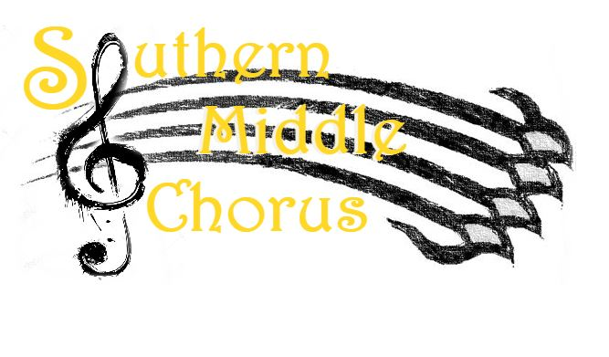
Chelsea Huber, Choral Director
chelsea_huber@abss.k12.nc.us
Introduction
Welcome to the General Music program at Southern Middle School! The Music Department at Southern is committed to excellence in music, while staying grounded in a sense of teamwork and collaboration. As a member of one of Southern’s general music classes, you will encounter many musical styles in order to learn musical skills and concepts. You will develop your own musical strengths such as discussing and writing about music, performing music, writing your own music, and more.
Purpose
The purpose of Southern’s general music classes is to give students tools to understand music while developing their strengths. Students will encounter music from all around the world and begin to develop their fluency in the language of music.

Please read this handbook in its entirety to become familiar with our expectations and procedures. The SMS Parent Info form and the Student/Parent Contract (the last two pages of this document) should be signed and returned no later than WEDNESDAY, SEPTEMBER 5TH. Returning this form on time will count as a quiz grade. If you have any questions or concerns, please do not hesitate to contact me. Thank you for your support of music education at Southern Middle School.

Both students and parents should sign up for their class’s Remind group using their phone number or email. To do so, text your class’s code to the number 81010.
Class codes
6th grade: @2g2c66
7th grade: @3427dk4
8th grade: @fch7g
General Music Classes

6th Grade General Music (9 weeks)
During the nine weeks of 6th grade general music, students will be introduced to basic musical skills and concepts in the areas of music literacy (reading and writing music), music history, and simple music performance. Basic rhythm and pitch notation will be explored through writing, movement, and other activities. Students will learn about the origins and eras of music starting in the Ancient period up until 1450.
7th Grade General Music (semester-long)
During a semester of 7th grade general music, students will further their music literacy skills, and encounter more advanced concepts in the areas of music composition, music history, music analysis, and music performance. By the end of the semester, students will have created various artifacts that prove their understanding of musical concepts, such as journal entries, musical compositions, visual examples, online media, and keyboard performances. Students will study Western music history from 1450 onward, as well non-Western cultures.
8th Grade General Music (semester-long)
During a semester of 8th grade general music, students will further their independence in music literacy skills, and encounter more advanced concepts in the areas of music composition, music history, music analysis, and music performance. By the end of the semester, students will have created various artifacts that prove their understanding of musical concepts, such as journal entries, musical compositions, visual examples, online media, and performances. 8th grade students are expected to apply their unique perspectives to the course material, in discussions about music and the artifacts they create through group work or independent study. Students will study many genres of Western and non-Western music, including the music of the 20th and 21st centuries.

Grading Procedures and Materials
Projects: 50% of final grade
Quizzes (including a weekly BOCA grade): 40% of final grade
Participation (preparedness, in-class participation): 10%

Projects:
Since projects make up half a students’ final grade, it is important that students use class time wisely to complete projects on time. A sufficient amount of class time will be given to complete projects; however, students may need to do work at home if they do not manage their class time well.
Quizzes:
Missed quizzes will be made up as soon as possible on a case-by-case basis. Students who miss a quiz day are not exempt from taking the quiz.
Most weeks, students will receive a quiz grade based on their completion of that week’s BOCAs (beginning of class activities). This grade is based on effort, not necessarily accuracy.
Required materials:
6th grade students:
- At least one pencil
- A two-pocket folder to keep in your shelf with loose-leaf paper inside
- I will give you staff (music notation) paper, but you can also print your own for free
7th and 8th grade students:
- At least one pencil
- A two-pocket folder AND a notebook, OR a 3-ring binder with paper inside
- I will give you staff (music notation) paper, but you can also print your own for free
Classroom Expectations and Procedures
The most important expectation of the music classroom is respect.
Respect for classmates: do not engage in behavior that would distract others, and always give supportive and kind feedback. Respect others’ opinions, even if they are not the same as yours. Encourage your classmates, especially when they are going outside their creative comfort zone.
Respect for your teacher: participate actively and do your best in EVERY activity no matter what.
Respect for yourself: Ask for help when needed. Don’t be afraid to try something that you might not be the best at.
Respect for the music: come to class prepared and ready to learn, and give the music your best effort.
Cell Phone Policy
Cell phones should not be present during class. However, there may be times when you can use your cellphone for a project or for research. When this is the case, Ms. Huber will let you know ahead of time.
Food/Gum/Water
You can drink WATER, and no other drinks (be sure to adhere to other teachers’ policies when you are in their class). No eating in the classroom. Spit out gum as soon as you enter the classroom.
When you enter class…
- Get your folder from the shelf BEFORE sitting down
- Take your seat and begin the BOCA that you see on the whiteboard.
- If it’s a Friday (no BOCA day), put your BOCAs from the week on your lap and wait for Ms. Huber to start class.
If you need to use the bathroom…
- Raise your hand and ask for permission.
- Plan to do this at the beginning at class, during BOCA time.
Parent Info Form and Signatures
*Please fill out and return by Wednesday, Sept. 5
Parent/Guardian Name:
Parent Email:
Parent Phone #:
Your child’s name:
Thank you for your information!

SMS Music Handbook Agreement form 2018-2019
*Please fill out and return by Wednesday, Sept. 5
I have read and understand all of the information in this handbook. I understand all the expectations and policies. I will do my best to uphold these expectations as an important member of the Music Program at Southern Middle.

Student’s Printed Name: _______________________

Signature of Student: ________________________

Signature of Parent/Guardian: _______________________

Date: ________________

